A000-Eur-**Germany-Vogelherdhöhle-Figurine-Mammoth-Bas Relief-Ivory-Mid. Paleolithic-**40-20 kya

[[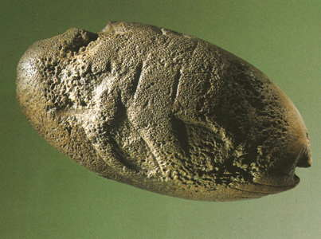](http://donsmaps.com/images25/mammothbasrelief.jpg)](http://donsmaps.com/images25/mammothbasrelief.jpg)  
  
**Germany-Vogelherdhöhle-Figurine-Mammoth-Bas Relief-Ivory-Middle Paleolithic-**40,000 BP-29,000 BP. After Müller-Beck and Albrecht 1987, original.

**Formal Label: Germany-Vogelherdhöhle-Figurine-Mammoth-Bas Relief-Ivory-Middle Paleolithic-**40,000 BP-29,000 BP.

**Display Description:**

**Accession Number:**

**LC Classification:**

**Date or Time Horizon:**

**Geographical Area:**

**Map, GPS Coordinates:**

**Cultural Affiliation:**

**Medium:**

**Dimensions:   
Weight:**

**Provenance:**

**Condition:**

**Discussion:**

**References:**

Length 69 mm, height 29 mm, breadth 36 mm.

**Müller-Beck, H. and Albrecht, G. (Ed.)**, 1987: *Die Anfänge der Kunst vor 30000 Jahren* Theiss: Stuttgart.